2021 CSE 40626 Final Project Status Report II

Prepared by

*Carter Goldman, Livia Johan, Christina Youn*

University of Notre Dame,

Notre Dame, IN, 46556

**1. Project Goal and Milestone**

For our project, we plan to create an image recognition model that can recognize American Sign Language letters (excluding J and Z because they require motion). For the second milestone, we said that we would have the model structure finalized, trained, and tested on the dataset. We also said that we would start testing the model on our own images and try to feed in a video stream.

**2. Tasks Completed So Far**

For the second milestone, we were able to finalize our model to achieve a testing accuracy of 95%. Our model now looks like this:

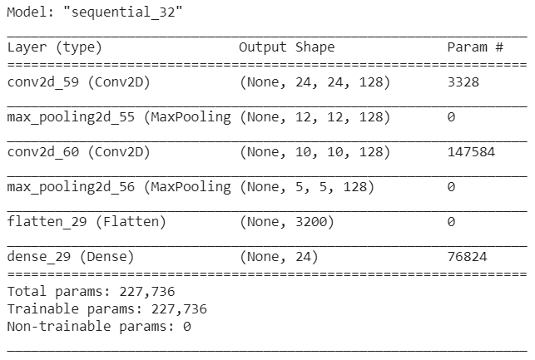

We were also able to test the model on images that were not part of the dataset. We took our own photos and had the model predict the signed letter. Here are what our photos look like:

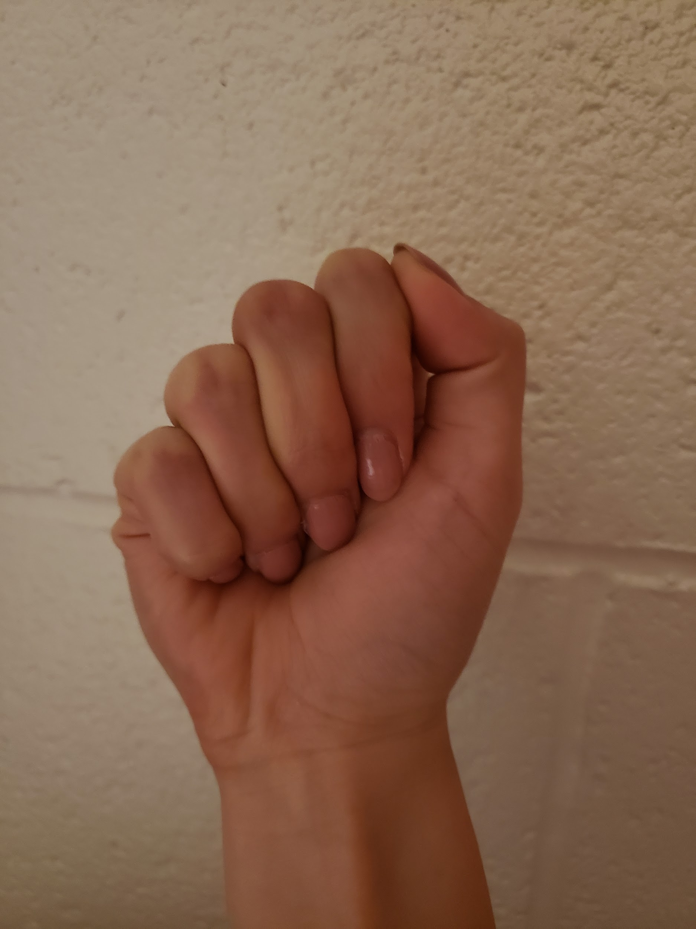 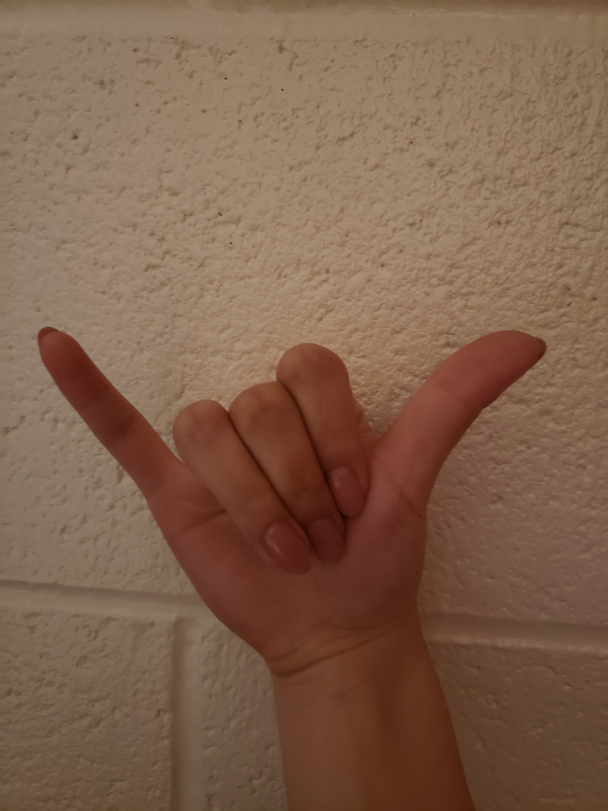

a.jpg y.jpg

Our model predicts ‘a.jpg’ as an ‘m’ and ‘y.jpg’ as an ‘y’. We think that these results are fine because the letters ‘a’ and ‘m’ look very similar. Furthermore, the images that we took look very different from the photos in the dataset, so it makes sense that our model struggled with our images. Using this code, we then started on the video feed.

**3. Team contribution**

How each of the team members contributed to the project so far.

*Livia & Carter*

* Fine-tuned the model (and ran the network with dozens of different parameters) to significantly increase the accuracy (82% → 95%)

*Christina*

* Took new images
* Wrote code to test these images
* Started on video feed code